**Web Programming Lab**

**Register Number:** 23BCE1777

**Name:** Madamsetty Sai Venkat Akshat

**Subject Code:** BCSE203E

**Subject Name:** Web Programming Lab

**Slot:** TE1/TE2

**Exercise-13**

**Code:(App.js)**

import React, { useState, Component } from "react";

function App() {

  const message = "Welcome to React!";

  const fruits = ["Apple", "Banana", "Cherry"];

  const days = ["Sunday", "Monday", "Tuesday", "Wednesday", "Thursday", "Friday", "Saturday"];

  const today = new Date().getDay();

  const ismorning = new Date().getHours() < 12;

  const [randomNumber, setRandomNumber] = useState(null);

  const [year, setYear] = useState(2024);

  const [num, setNum] = useState("");

  const [text, setText] = useState("");

  const isLeapYear = (year % 4 === 0 && year % 100 !== 0) || year % 400 === 0;

  const isPrime = (num) => {

    if (num < 2) return false;

    for (let i = 2; i <= Math.sqrt(num); i++) {

      if (num % i === 0) return false;

    }

    return true;

  };

  const reversedText = text.split("").reverse().join("");

  const isPalindrome = text.toLowerCase() === reversedText.toLowerCase();

  return (

    <div style={{ padding: "10px", fontFamily: "Arial" }}>

      <h1>Hello, React!</h1>

      <h2>{message}</h2>

      <h3>Fruits List:</h3>

      <ul>

        {fruits.map((fruit, index) => (

          <li key={index}>{fruit}</li>

        ))}

      </ul>

      <p style={{ color: "blue", fontSize: "20px", fontWeight: "bold" }}>

        This is a styled message!

      </p>

      <p>Sum of squares: {3 ** 2 + 4 ** 2}</p>

      <h3>{ismorning ? "Good Morning" : "Good Evening"}</h3>

      <p>Today is {days[today]}.</p>

      <div style={{ padding: "20px", fontFamily: "Arial" }}>

        <h1>Prime Number Checker</h1>

        <input

          type="number"

          value={num}

          onChange={(e) => setNum(e.target.value)}

          placeholder="Enter a number"

        />

        {num && (

          <p>{num} is {isPrime(parseInt(num)) ? "a prime number" : "not a prime number"}.</p>

        )}

        <hr />

        <h1>Reverse String & Palindrome Checker</h1>

        <input

          type="text"

          value={text}

          onChange={(e) => setText(e.target.value)}

          placeholder="Enter a string"

        />

        {text && (

          <>

            <p>Reversed: {reversedText}</p>

            <p>{isPalindrome ? "It is a palindrome" : "It is not a palindrome"}.</p>

          </>

        )}

      </div>

      <button onClick={() => setRandomNumber(Math.floor(Math.random() * 100) + 1)}>

        Generate Number

      </button>

      {randomNumber !== null && <p>Random Number: {randomNumber}</p>}

      <p>{year} is {isLeapYear ? "a Leap Year" : "not a Leap Year"}.</p>

      <UserGreeting firstName="Akshat" lastName="MSV" />

      <TemperatureConverter />

    </div>

  );

}

// Class Component - Temperature Converter

class TemperatureConverter extends Component {

  constructor() {

    super();

    this.state = { celsius: "", fahrenheit: "" };

  }

  convertToFahrenheit = (e) => {

    const celsius = e.target.value;

    this.setState({

      celsius,

      fahrenheit: (celsius * 9/5 + 32).toFixed(2)

    });

  };

  convertToCelsius = (e) => {

    const fahrenheit = e.target.value;

    this.setState({

      fahrenheit,

      celsius: ((fahrenheit - 32) * 5/9).toFixed(2)

    });

  };

  render() {

    return (

      <div>

        <input type="number" placeholder="Celsius" value={this.state.celsius} onChange={this.convertToFahrenheit} />

        <p>Celsius: {this.state.celsius}</p>

        <input type="number" placeholder="Fahrenheit" value={this.state.fahrenheit} onChange={this.convertToCelsius} />

        <p>Fahrenheit: {this.state.fahrenheit}</p>

      </div>

    );

  }

}

// Class Component - User Greeting

class UserGreeting extends Component {

  render() {

    return <h1>Hello, {this.props.firstName} {this.props.lastName}!</h1>;

  }

}

export default App;

**Output:**

* When u enter number in prime number checker output is produced.
* When u enter string in palindrome checker output is generated
* When u click generate random number button random number is generated and output is showed.

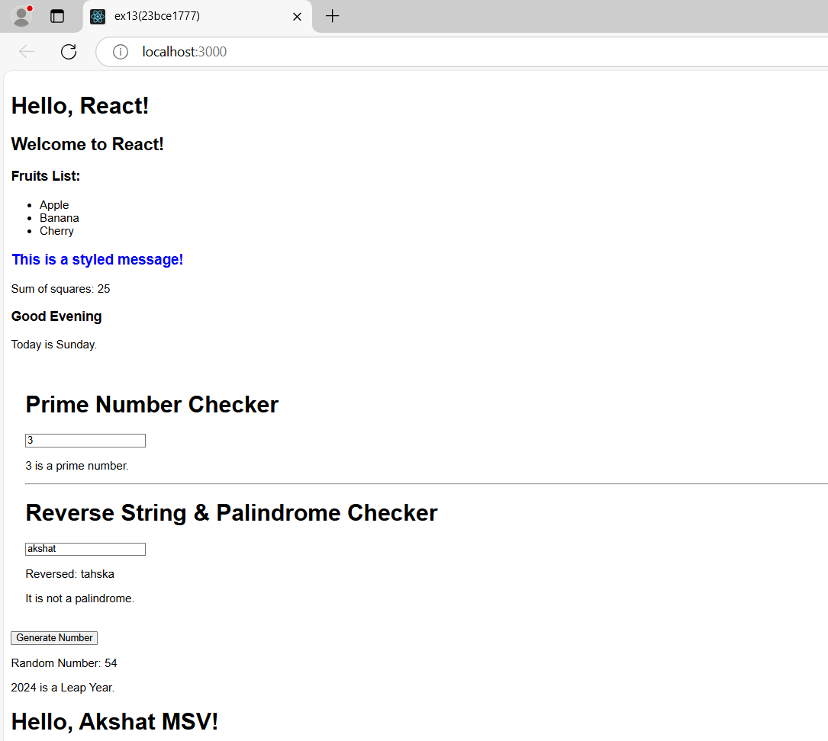

* Give your input values either in Celsius or Fahrenheit section to get other one as output.

